**Project Design Phase II**

**Data Flow Diagram & User Stories**

| Date | 6 March 2025 |
| --- | --- |
| Team ID | SWTID1741257475147583 |
| Project Name | FitFlex |
| Maximum Marks | 4 Marks |

**Data Flow Diagrams:**

A Data Flow Diagram (DFD) is a traditional visual representation of the information flows within a system. A neat and clear DFD can depict the right amount of the system requirement graphically. It shows how data enters and leaves the system, what changes the information, and where data is stored.

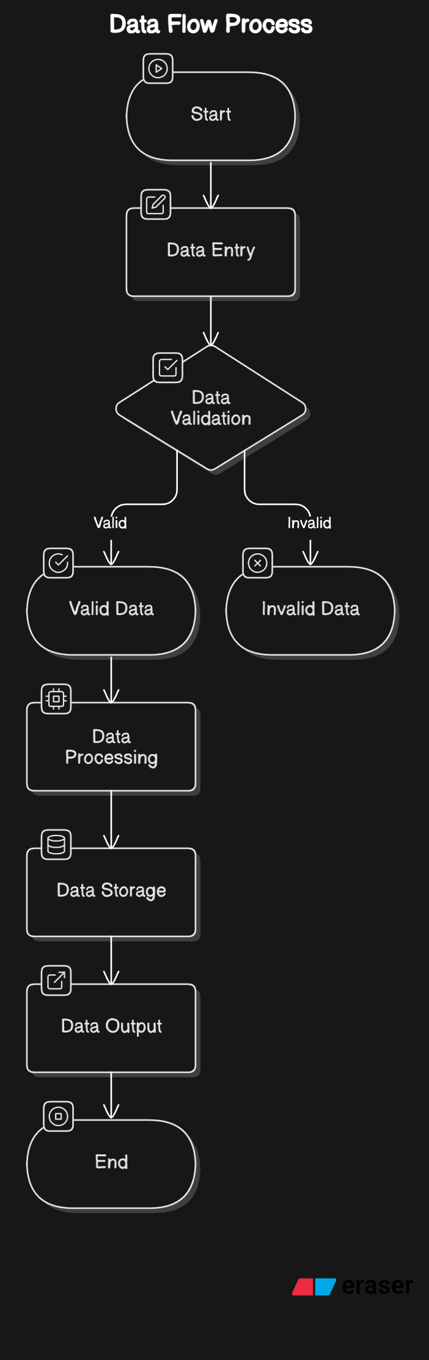

• **Start Point**: The process begins with a **user action** (such as logging in, entering data, or submitting a request).

• **Data Entry**: The system captures input from users (such as login credentials, workout logs, or payment details).

• **Data Validation**: Once the input is received, the system performs a **validation check** to determine whether the data is valid or invalid.

* **Valid Data**: If the input meets the required format and criteria, it proceeds to the next stage.
* **Invalid Data**: If the input is incorrect, the system rejects it and prompts the user to re-enter correct data.

• **Data Processing**: After validation, the data is processed according to business rules, such as calculating workout progress, updating fitness goals, or verifying payments.

• **Data Storage**: The processed data is stored in the appropriate database:

* **User Database**: Stores user profiles, preferences, and authentication details.
* **Workout Database**: Contains fitness routines, logs, and progress tracking.
* **Transaction Database**: Records payments and subscriptions.

• **Data Output**: Once the data is processed and stored, relevant information is displayed back to the user in the form of dashboards, reports, or notifications.

• **End Point**: The process concludes when the system successfully completes the transaction and provides the user with the expected output.

**User Stories:**

|  |  |  |  |
| --- | --- | --- | --- |
| **ID** | **User Role** | **Story Description** | **Acceptance Criteria** |
| US001 | As a user | I want to sign up and log in securely | User can register, receive confirmation, and log in successfully. |
| US002 | As a trainer | I want to upload workout programs | I want to upload workout programs |
| US003 | As a user | I want to log my daily workouts | Workout details are saved and progress is updated. |
| US004 | As a user | I want to subscribe and make payments | Payment is processed successfully, and access is granted. |